**Project outline:-**

Company Lockers Pvt. Ltd. is looking for command line java application (desktop application prototype) to manage their file on given drive. Java concepts being used in the project . Data Structures where sorting and searching techniques are used. Option to close the application.

**Product’s capabilities :-**

1. Display all Files, Folders (In Ascending Order).

2. Add a new file in given projectFilesPath

3. Delete a file.

4. Search a file.

5. Exit from Application.

**Appearance**:- Windows command line operations, from standard keyboard input.

**Input screen:-**

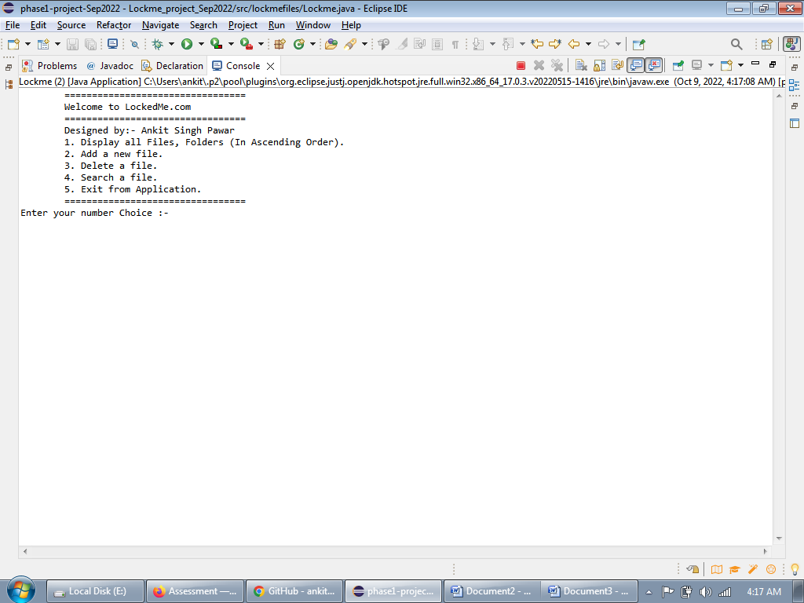

**output screen:-1**

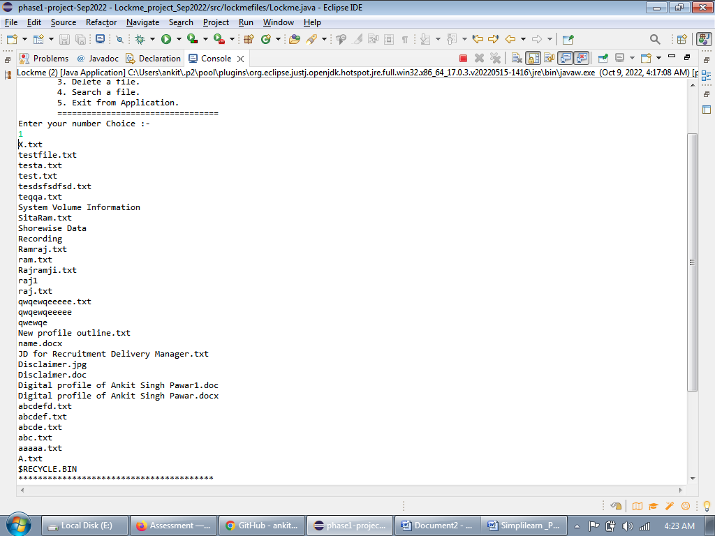

**output screen:-2**

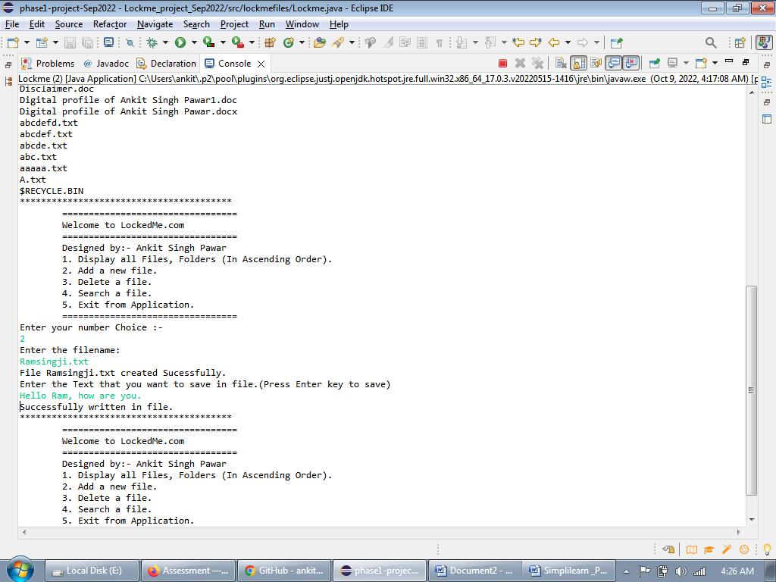

**output screen:-3**

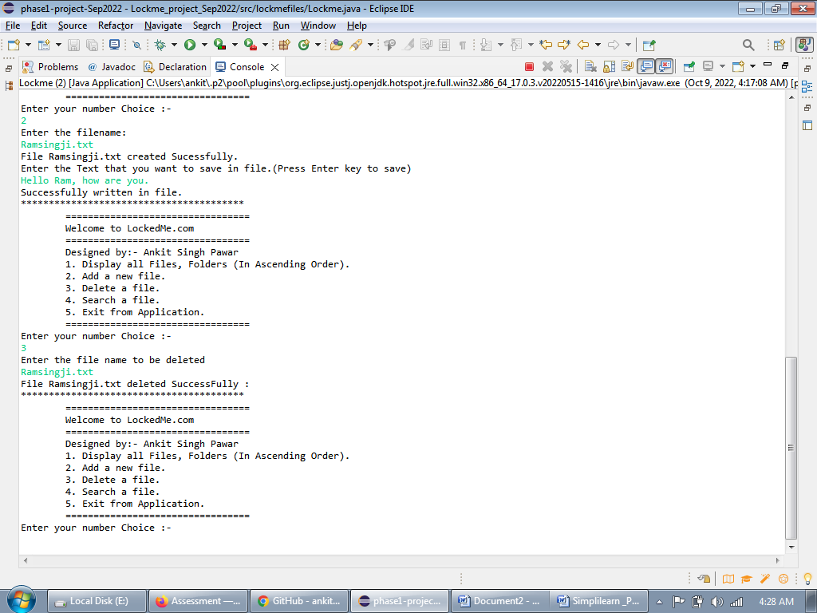

**output screen:-4**

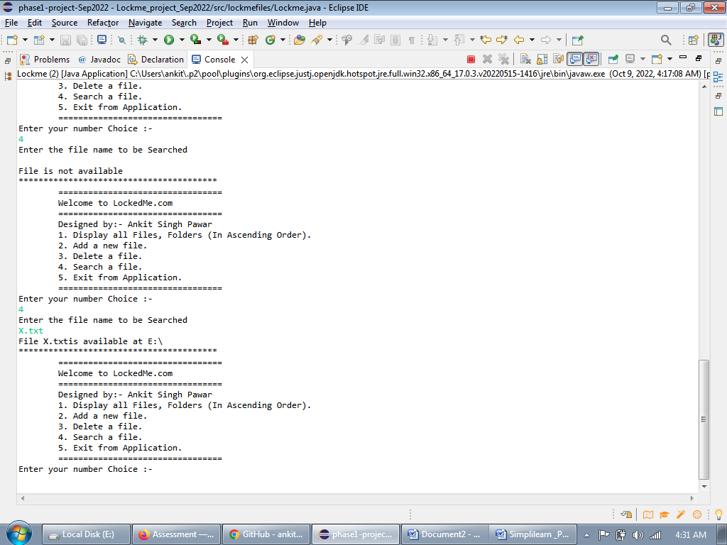

**output screen:-5**

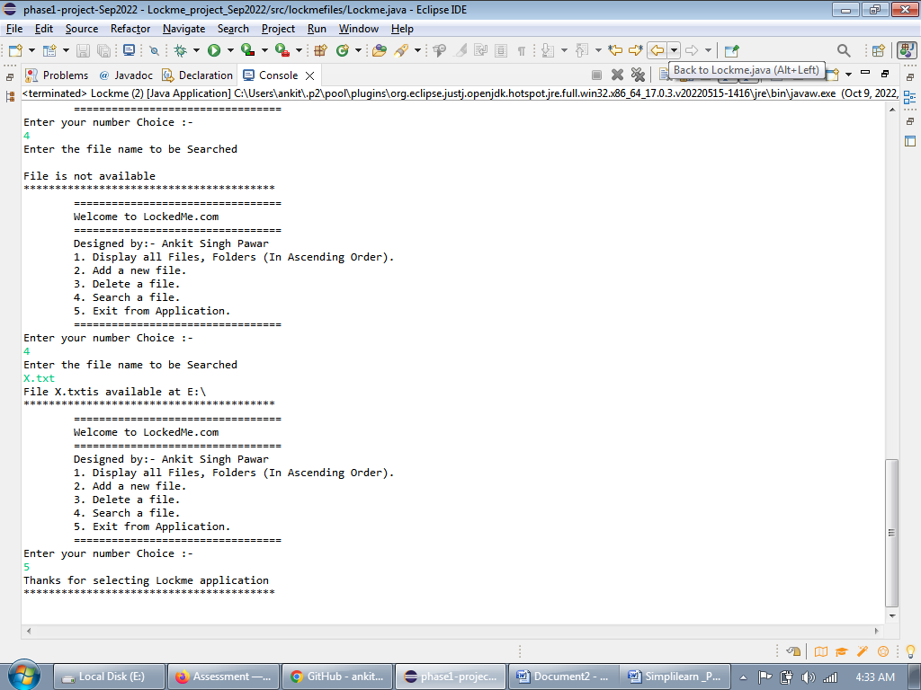

**Project development model:**

*we have used* Agile Project Management approach, with 3 *sprints.* The duration of each sprint is (1 weeks). The total delivery time would be (3 weeks).

**Source code management and version control :- As agreed we use (**Set up) Git and GitHub account to store and track enhancements of the prototype. The link will be shared as per MOS.

**User interactions:-** Single user, command line interface with no GUI.

**Support help: -** Please contact admin: admin@LockedMe.Com

**Escalation matrix -** Please contact Ankit Singh Pawar( on call between 8:am IST to 8:pm IST).

**The flow and features of the application:**

**Flow chart(HLD):-**

1

Display all Files

2

Yes

Add a new file

input 1 to 5

Welcome screen with 5 options

3

Delete a file

Enter correct IO

5

4

No

Exit

Search a file

**Features of the application:**

Add a file to the existing directory list.

Delete a user specified file from the existing directory list.

Return a message if FNF (File not found)

Search a user specified file from the main directory.